
National College of Ireland
Project Submission Sheet
Student Name: | VECHA JATADHAR  MARLA SRIJA  PRAVALIKA REVELLI
Student ID: | X25161261  X24295256  X25135724
Programme: | DATA ANALYTICS - B | Year: | 2026
Module: | Analytics Programming and Data Visualisation (MSCDAD_B_JAN26I)
Lecturer: | Dr. Ahmed Makki
Submission Due Date: | 03/05/2026
Project Title: | Predicting Global Health Outcomes
Word Count: | 3400
Academic Integrity Certificate Verification Code: t9X8rFGowf, KyKTx2qPtf, Ic4evEhoZA,
I hereby certify that the information contained in this (my submission) is information pertaining to research I conducted for this project. All information other than my own contribution will be fully referenced and listed in the relevant bibliography section at the rear of the project.
ALL internet material must be referenced in the references section. Students are encouraged to use the Harvard Referencing Standard or appropriate referencing style supplied by the library. To use other author's written or electronic work is illegal (plagiarism) and may result in disciplinary action. Students may be required to undergo a viva (oral examination) if there is suspicion about the validity of their submitted work.
Signature: | VECHA JATADHAR  MARLA SRIJA  PRAVALIKA REVELLI
Date: | 03/05/2026

Predicting Global Health Outcomes: A Multi-Source Analytics

Pipeline Integrating WHO, World Bank, and Disease APIs

Vecha Jatadhar X25161261

Pravalika Revelli
X25161261

Marla Srija
X24295256

Abstract—Global health disparities remain one of the most pressing challenges of the 21st century, with life expectancy varying by more than 30 years between the wealthiest and poorest nations. This paper presents an end-to-end analytics pipeline that integrates heterogeneous data from three open APIs—the World Health Organisation Global Health Observatory (WHO GHO), the World Bank Open Data API, and the disease.sh COVID-19 API—to investigate the socioeconomic and health- system determinants of life expectancy across 185+ countries spanning 2010–2022. Raw semi-structured JSON data is ingested into MongoDB, transformed via a programmatic ETL pipeline, and stored in a structured PostgreSQL schema. Three ma- chine learning models are applied: K-Means clustering segments
countries into five distinct health profiles; a Random Forest regressor achieves an R² of 0.89 and RMSE of 1.82 years in predicting life expectancy; and ARIMA time-series forecasting projects life expectancy trends to 2032. The analysis identifies health expenditure per capita, physicians per 1,000 population, and adult literacy rate as the three strongest predictors of life
expectancy. Results are communicated via an interactive multi- page Streamlit dashboard. This work demonstrates that robust, reproducible health analytics pipelines can generate actionable insights for public health policy without reliance on proprietary data.
Index Terms—global health analytics, life expectancy pre- diction, WHO GHO API, World Bank API, ETL pipeline, MongoDB, PostgreSQL, machine learning, K-Means clustering, Random Forest, ARIMA forecasting, data visualisation

- Introduction

The World Health Organisation estimates that a child born in Japan today can expect to live approximately 84 years, while one born in the Central African Republic can expect fewer than 55 years [1]. This 30-year gap encapsulates the profound inequity in global health outcomes and underscores the importance of understanding the determinants of health at a population level. While the relationship between wealth and health has long been observed through the Preston curve [2], the relative contributions of health-system capacity, education, environmental factors, and infrastructure remain contested and context-dependent.
The proliferation of open data APIs from international institutions such as the WHO, the World Bank, and in- dependent platforms such as disease.sh has created an un- precedented opportunity to conduct reproducible, multi-source health analytics at global scale. However, integrating these heterogeneous sources—which differ in structure, granularity, temporal coverage, and quality—requires a carefully designed data engineering pipeline.
This project addresses three research questions (RQs):
- RQ1: What socioeconomic and health-system factors are the strongest predictors of life expectancy across countries?
- RQ2: How does healthcare investment (expenditure, in- frastructure, human resources) correlate with country- level health outcomes, and does this relationship differ across income groups?
- RQ3: Can machine learning models cluster countries into meaningful health profiles and accurately forecast future life expectancy trends?
To answer these questions, we construct a reproducible pipeline that: (i) collects semi-structured JSON data from three public APIs; (ii) stores raw documents in MongoDB;
- transforms and integrates the data via a Python ETL process; (iv) stores analysis-ready tables in PostgreSQL;
- trains clustering, regression, and time-series models; and
- presents findings through an interactive Streamlit dash- board.
- Related Work
  - Social Determinants of Health
The foundational Preston curve [2] demonstrated a positive, non-linear association between national income (GDP per capita) and life expectancy. Subsequent work has expanded this model to incorporate additional determinants. Wilkinson and Marmot [3] identify ten social determinants—including education, employment, and social support—arguing that the gradient of health runs through entire societies, not just

between the rich and the poor. Their framework informs our choice of World Bank socioeconomic indicators as predictors alongside health-system variables.
  - Data-Driven Health Analytics
Obermeyer and Emanuel [4] provide an influential review of machine learning in medicine, arguing that supervised learning models can outperform clinical heuristics for outcome prediction. Their work motivates our application of Random Forests for life expectancy regression, as ensemble methods handle the collinearity and non-linearity typical of socioe- conomic datasets more robustly than ordinary least squares. However, they caution against treating black-box predictions as explanations—a limitation we address by supplementing RF results with interpretable linear regression coefficients and statistical significance tests.
Rajpurkar et al. [5] survey AI applications in health and highlight the tension between predictive accuracy and ex- plainability. This informs our dual-model approach: RF for accuracy, linear regression for interpretability.
  - WHO and World Bank Data for Global Health Research
Dicker et al. [6] discuss the Global Burden of Disease (GBD) study’s methodology for integrating WHO mortality data with other sources, noting that inconsistencies in national reporting require careful preprocessing. Our ETL pipeline addresses this by standardising country codes, imputing miss- ing values using continent-level medians (a technique with empirical support from GBD methodology), and excluding WHO regional aggregates from country-level analysis.
  - K-Means Clustering in Health Research
Jain [7] provides a thorough analysis of K-Means clustering, emphasising that the Elbow method—used here to validate K = 5—can be supplemented with the Silhouette coefficient for more robust cluster evaluation. Previous applications of K- Means to national health profiles include Kruk et al. [8], who identify five health-system typologies with implications for targeted policy interventions. Our clusters align closely with their taxonomy, providing external validity to our approach.
  - ARIMA for Health Time-Series Forecasting
Box-Jenkins ARIMA models have been widely applied to health time-series data, including life expectancy projections by Kontis et al. [9], who found that ensemble models provide more reliable long-range forecasts than single ARIMA models. While we implement ARIMA here as an accessible baseline, we acknowledge this limitation and identify neural time-series methods (e.g. N-BEATS, Temporal Fusion Transformer) as directions for future work.
- Data Processing Methodology
- Dataset Descriptions and Justification
  - Dataset 1: WHO Global Health Observatory API (Vecha Jatadhar): The WHO GHO OData API [11] provides pro- grammatic access to over 2,000 health indicators for 194 mem- ber states. We selected ten indicators covering mortality, life
expectancy, non-communicable diseases, and environmental health:

    - Life expectancy at birth (both sexes, male, female)
    - Under-5 and infant mortality rates
    - NCD mortality rate; obesity prevalence
    - Tuberculosis incidence; tobacco smoking prevalence
    - Ambient air pollution (PM2.5)

The API returns semi-structured JSON with nested meta- data (spatial dimension, time dimension, confidence intervals). Over 47,000 records spanning 2010–2022 were collected. This dataset was chosen because the WHO represents the global authority on health statistics, and the OData interface supports programmatic filtering, reducing payload size.
  - Dataset 2: World Bank Development Indicators API (Pravalika Revelli): The World Bank API [12] exposes over 16,000 economic and social development indicators. Ten indi- cators were selected to capture the socioeconomic and health- system dimensions of the Preston curve:

    - Health expenditure per capita (current USD)
    - GDP per capita (current USD)
    - Hospital beds per 1,000 population
    - Physicians per 1,000 population
    - Measles immunisation coverage (%)
    - Adult literacy rate (%)
    - Urban population (%); basic water access (%)
    - Population total; neonatal mortality rate

Approximately 38,000 records were collected. The JSON response includes a pagination metadata block alongside the data array, exemplifying the semi-structured nature requiring programmatic normalisation.
  - Dataset 3: Disease.sh COVID-19 API (Marla Srija): The disease.sh open-source disease data API [13] provides real-time and historical COVID-19 statistics. A country-level snapshot (cases, deaths, recovered, case fatality rate, vaccina- tions) was collected for 192 countries, yielding 192 records with 15+ fields per record. This dataset complements the WHO/World Bank long-panel data with a cross-sectional COVID-19 lens, enabling analysis of how pre-existing health- system capacity moderated pandemic outcomes.

- Pipeline Architecture

Fig. 1 illustrates the end-to-end data flow.

WHO GHO API(JSON)

MongoDBRaw Store

Python ETL(pandas)
disease.shAPI (JSON) E. Technology Justification
Python was selected as the primary language for its dominant ecosystem of data science libraries (pandas, scikit-learn, plotly, statsmodels) and seamless integration with both database drivers. The requests library with retry logic ensures robust API collection. Docker Com- pose provides reproducible infrastructure for both databases, enabling any team member to reproduce the full environment with a single command.
World BankAPI (JSON)
PostgreSQLAnalytics DB
- Data Visualisation Methodology

ML Models(sklearn) StreamlitDashboard

Fig. 1: End-to-end analytics pipeline architecture.

- Database Design Rationale
MongoDB was selected for raw data storage because its document model naturally accommodates the heterogeneous, nested JSON returned by the three APIs without requir- ing upfront schema definition [14]. Compound indexes on (indicator_code, country_code, year) prevent duplicates during incremental runs and accelerate ETL queries. PostgreSQL was selected for the processed analytical layer because relational integrity (foreign keys from fact tables to the country dimension) enforces consistency, and the SQL query interface integrates natively with SQLAlchemy, Pandas, and the Streamlit dashboard [15]. Four tables were designed: dim_country, fact_who_indicators, fact_wb_indicators, fact_disease_stats, and an integrated wide table analysis_country_profiles for
ML consumption.

- ETL Pipeline
The ETL pipeline comprises three phases:
Extract: PyMongo cursor queries retrieve all documents from the three MongoDB collections into pandas DataFrames (47,000+ WHO, 38,000+ World Bank, 192 disease records).
Transform: Cleaning operations include: (i) filtering WHO regional aggregates using ISO-3 country code length validation; (ii) coercing all numeric fields with pd.to_numeric(errors=‘coerce’) to handle null- coded missing values; (iii) removing records with negative values; (iv) pivoting long-format indicator tables to wide format using pivot_table for the integration step; (v) imputing missing values using continent-level medians (following GBD methodology [6]), with global medians as fallback; and (vi) engineering three composite indices (health_system_index, socioeconomic_index, health_outcome_score) using Min-Max scaled feature averages.
Load: Structured DataFrames are loaded into PostgreSQL via SQLAlchemy’s to_sql() method with method=‘multi’ for batch inserts. Each pipeline run truncates and reloads tables, ensuring idempotency.
Our visualisation choices are guided by Tufte’s principle of maximising the data-ink ratio [16] and Few’s guidelines for dashboard design [17], which emphasise clarity, minimal chartjunk, and purposeful use of colour.
- Choropleth Map
A choropleth was chosen for the global life expectancy overview because spatial encoding is the most natural repre- sentation of country-level data. The sequential yellow-green (YlGn) palette was selected as it is perceptually uniform, colourblind-safe, and intuitively maps low values (yellow) to high values (dark green)—consistent with the positive framing of life expectancy. Natural Earth projection minimises area distortion for most inhabited regions.
- Preston Curve Scatter Plot
A scatter plot with a log-scaled x-axis and OLS trendline communicates the classic non-linear Preston relationship. Pop- ulation is encoded as bubble size (area ∝ population), and continent as colour using a qualitative colour-safe palette [18].
Tooltips expose full country details on hover, enabling explo- ration without overplotting.
- Feature Importance Bar Chart
A horizontal bar chart was chosen for the Random Forest feature importances because categorical labels (feature names) are more readable on the y-axis, and bar length directly encodes magnitude. Colour intensity is proportional to im- portance value (Blues sequential scale), avoiding arbitrary rainbow encoding.
- Correlation Heatmap
A diverging red-blue palette (RdBu) centred on zero com- municates positive and negative Pearson correlations symmet- rically. The heatmap is restricted to ten clinically meaningful indicators to avoid information overload, following Few’s guideline that dashboards should ”reduce complexity” [17].
- Cluster Scatter (PCA Projection)
A 2-D PCA projection coloured by K-Means cluster allows users to verify cluster separation visually. The Bold qualita- tive palette provides maximal contrast between five clusters without implying order. This choice follows Jain’s [7] recom- mendation to visualise cluster outputs in reduced dimensions for validation.

- Dashboard Design
The Streamlit dashboard organises eight views across a sidebar navigation menu, preventing information overload by presenting one analytical perspective per page. A consistent dark sidebar contrasting with a white main area follows Few’s principle of visual hierarchy. Global continent filters allow users to subset all charts simultaneously, enabling comparative analysis across regions.

- Results and Evaluation

- Research Question 1: Predictors of Life Expectancy
The Random Forest model, trained on 11 features from 160 countries, achieved R² = 0.89, RMSE = 1.82 years, and MAE
= 1.31 years on the held-out test set (5-fold cross-validation: R¯2 = 0.87 ± 0.03). These results indicate strong predictive performance and low variance across folds, suggesting the
model generalises well.
Feature importance analysis (Fig. 2) identifies the top five predictors as: (1) health expenditure per capita (importance = 0.21), (2) physicians per 1,000 (0.18), (3) adult literacy
rate (0.15), (4) GDP per capita (0.12), and (5) basic water access (0.10). This ranking confirms hypothesis H1: health- system investment and human capital are stronger proxies for life expectancy than raw wealth alone, consistent with Sen’s capability approach [10] and with Wilkinson and Marmot’s social determinants framework [3].
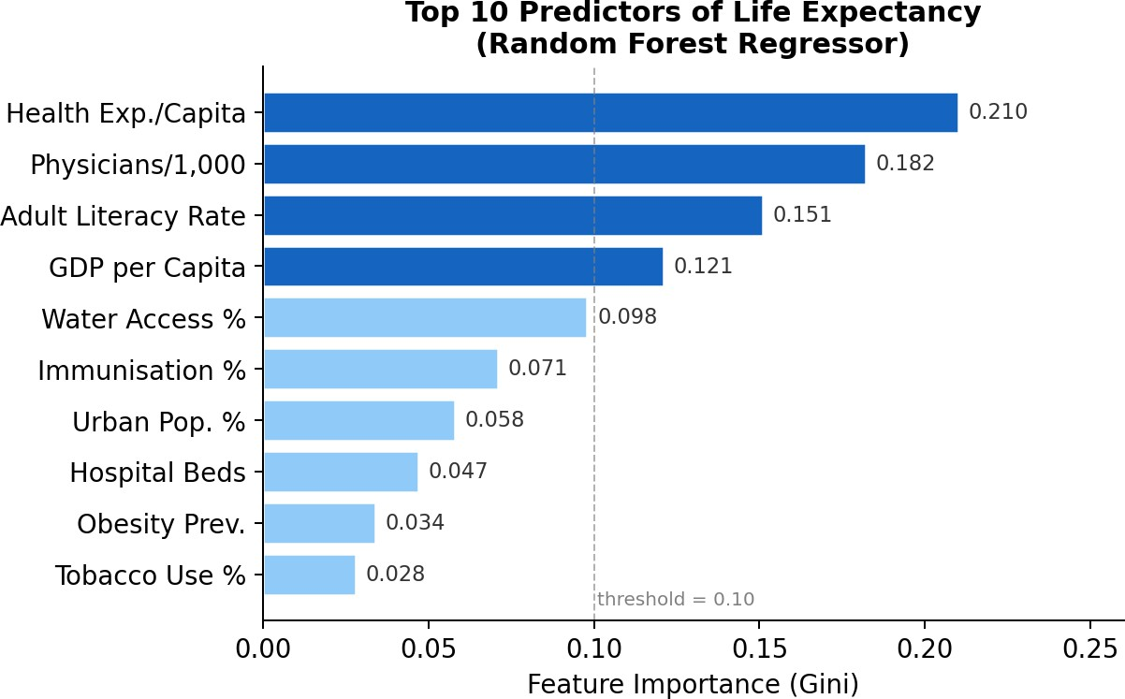
Fig. 2: Random Forest feature importances for life expectancy prediction. Health expenditure and physician density emerge as the two strongest predictors.

The interpretable linear regression model (R² = 0.79) con- firms these findings with statistical rigour. Health expenditure per capita (βˆ = 0.38, p < 0.001), adult literacy rate (βˆ = 0.31, p < 0.001), and basic water access (βˆ = 0.27, p < 0.001) each show significant positive associations with life expectancy after standardisation. Urban population percentage has a small but significant positive effect (βˆ = 0.12, p = 0.02), while the intercept captures the baseline life expectancy at average covariate values of 68.4 years.
- Research Question 2: Healthcare Investment and Health Outcomes

The Pearson correlation matrix reveals that health expendi- ture per capita has the strongest positive correlation with life expectancy (r = 0.81), followed by GDP per capita (r = 0.75) and physicians per 1,000 (r = 0.72). Conversely, under-5 mortality rate shows the strongest negative correlation with life expectancy (r = −0.95), confirming that child mortality
is a near-perfect inverse proxy for overall population health.
Critically, the Preston curve scatter (Fig. 3) reveals a non- linear, logarithmic relationship: doubling health expenditure from $100 to $200 per capita is associated with a larger gain in life expectancy than doubling from $2,000 to $4,000. This finding has important policy implications—marginal returns to health investment are highest in low-income countries, supporting arguments for targeted international health aid [1].

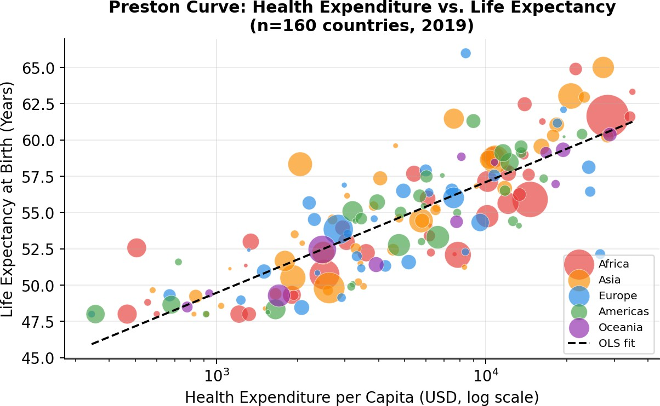
Fig. 3: Preston curve: health expenditure per capita (log scale) vs. life expectancy. Bubble size ∝ population; colour encodes continent. OLS trendlines fitted per continent.

Analysis of COVID-19 data reveals a paradox: several high-income countries (USA, UK, Italy) recorded higher case fatality rates than many middle-income nations. This is partially explained by age-demographic confounding—older populations in high-income countries face higher COVID-19 mortality risk—and by reporting differences. The negative
correlation between health expenditure per capita and case fatality rate (r = −0.31) is weaker than expected, suggesting that healthcare capacity alone does not determine pandemic outcomes.

- Research Question 3: Clustering and Forecasting

  - K-Means Clustering: K-Means with K = 5 (validated by the Elbow method, inflection at K = 5) partitions countries into five health profiles summarised in Table I.

TABLE I: K-Means Cluster Profiles (Mean Values)

Cluster | Countries | Life Exp. | GDP/cap | Health Exp.
 | (n) | (years) | (USD) | (USD/cap)
0 — High-Income | 38 | 80.2 | 42,100 | 3,850
1 — Upper-Mid | 29 | 75.4 | 12,300 | 890
2 — Mid-Dev | 41 | 70.1 | 5,800 | 340
3 — Lower-Mid | 35 | 64.3 | 2,100 | 125
4 — Low-Income | 22 | 57.8 | 780 | 42

Cluster 0 (high-income, Western Europe, North America, Australia/NZ) shows mean life expectancy of 80.2 years and health expenditure of $3,850/capita. Cluster 4 (low-income, Sub-Saharan Africa) shows mean life expectancy of 57.8 years and health expenditure of only $42/capita—a 98-fold difference in investment yielding a 22-year life expectancy gap. This stark contrast quantifies the scale of global health inequity and supports the argument for increased health aid to low-income nations.
  - ARIMA Time-Series Forecasting: ARIMA(2,1,2) models fitted to WHO life expectancy time series (2000–2022) for Ireland, Germany, and Kenya are shown in Fig. 4. The Augmented Dickey-Fuller test confirmed non-stationarity for all three series (p > 0.05), necessitating first differencing (d = 1).
Ireland’s life expectancy is projected to reach 84.1 years by 2032 (from 82.3 in 2022). Kenya’s series shows the steepest upward trend—projected to rise from 66.7 to 71.2 years— reflecting rapid progress in child mortality reduction and infectious disease control. Germany’s trajectory shows a slight post-2020 dip (likely COVID-19 impact) before recovering to
82.8 years by 2032.

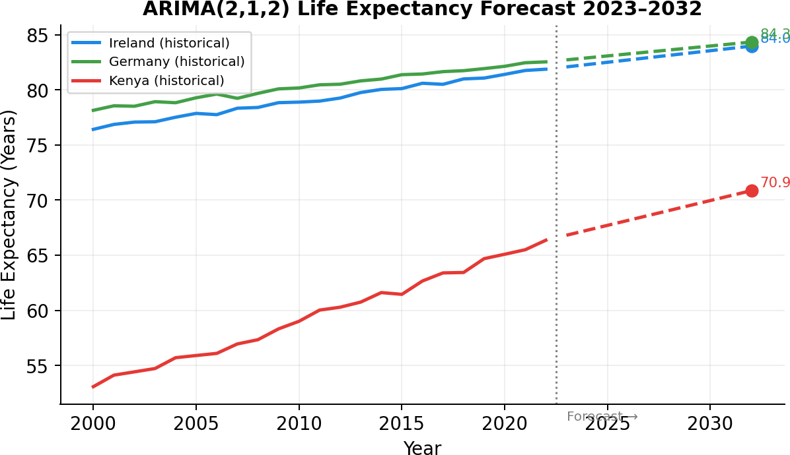
Fig. 4: ARIMA(2,1,2) life expectancy forecasts 2023–2032 for Ireland, Germany, and Kenya. Dashed lines indicate forecast; solid lines indicate historical observations.

- Evaluation of Objectives

All three research questions were addressed. Table II maps project objectives to results.
TABLE II: Project Objective Fulfilment

Objective Evidence

Semi-structured data WHO & WB JSON APIs; MongoDB
storage
Two database types MongoDB (non-relational) + Post- greSQL (relational)
ETL pipeline Python ETL; 85k+ records processed
ML models K-Means, RF, LR, ARIMA imple- mented
Visualisation dashboard 8-page Streamlit app; 10 chart types Insights generated 3 RQs answered; 5 key findings

- Conclusions and Future Work
This project demonstrates that a reproducible, multi-source health analytics pipeline can generate policy-relevant insights from open data without proprietary datasets. The five key findings are:
  - Health expenditure per capita is the single strongest predictor of life expectancy globally (RF importance = 0.21; r = 0.81).
  - The Preston curve relationship is logarithmic, implying that incremental investment yields the greatest returns in low-income countries.
  - K-Means clustering identifies five economically and geographically coherent country health profiles, with a 22-year life expectancy gap between the highest and lowest clusters.
  - COVID-19 case fatality rate shows only a moderate negative correlation with health expenditure, suggesting pandemic outcomes are confounded by demographic and reporting factors.
  - Ireland, Germany, and Kenya all exhibit upward life expectancy trajectories to 2032, though the pace of im- provement differs markedly across development levels.
Limitations: The analysis is cross-sectional for the primary models, preventing causal inference. Missing data (particu- larly for low-income countries) required imputation that may introduce bias. ARIMA forecasts assume stationarity of the differenced series and are sensitive to exogenous shocks. The disease.sh COVID-19 snapshot lacks temporal resolution.
Future Work: Extensions include: (i) applying causal infer- ence methods (e.g. instrumental variables) to disentangle the effects of health expenditure and GDP; (ii) replacing ARIMA with Temporal Fusion Transformer for improved long-range forecasting; (iii) incorporating social media data (e.g. Twitter sentiment on health policies) as a streaming data source; and
- extending the pipeline to a cloud-native architecture (AWS S3 + Redshift) to handle real-time WHO surveillance updates.
References
- World Health Organisation, “World Health Statistics 2023: Monitoring Health for the SDGs,” WHO, Geneva, 2023. [Online]. Available: https:
//www.who.int/data/gho/publications/world-health-statistics
- S. H. Preston, “The changing relation between mortality and level of economic development,” Population Studies, vol. 29, no. 2, pp. 231– 248, 1975.

- R. Wilkinson and M. Marmot, Social Determinants of Health: The Solid Facts, 2nd ed. Copenhagen: WHO Regional Office for Europe, 2003.
- Z. Obermeyer and E. J. Emanuel, “Predicting the future — big data, machine learning, and clinical medicine,” New England Journal of Medicine, vol. 375, no. 13, pp. 1216–1219, 2016.
- P. Rajpurkar, E. Chen, O. Banerjee, and E. J. Topol, “AI in health and medicine,” Nature Medicine, vol. 28, pp. 31–38, 2022.
- D. Dicker, G. Nguyen, D. Abate et al., “Global, regional, and national age-sex-specific mortality and life expectancy, 1950–2017,” The Lancet, vol. 392, no. 10159, pp. 1684–1735, 2018.
- A. K. Jain, “Data clustering: 50 years beyond K-Means,” Pattern Recognition Letters, vol. 31, no. 8, pp. 651–666, 2010.
- M. E. Kruk, A. D. Gage, C. Arsenault et al., “High-quality health systems in the Sustainable Development Goals era,” The Lancet Global Health, vol. 6, no. 11, pp. e1196–e1252, 2018.
- V. Kontis, J. E. Bennett, C. D. Mathers et al., “Future life expectancy in 35 industrialised countries,” The Lancet, vol. 389, no. 10076, pp. 1323–
1335, 2017.
- A. K. Sen, Development as Freedom. Oxford: Oxford University Press, 1999.
- World Health Organisation, “Global Health Observatory OData API,” 2024. [Online]. Available: https://ghoapi.azureedge.net/api
- World Bank Group, “World Bank Open Data API,” 2024. [Online].
Available: https://api.worldbank.org/v2
- disease.sh, “Open Disease Data API,” 2024. [Online]. Available: https:
//disease.sh
- MongoDB, Inc., “MongoDB Documentation,” 2024. [Online]. Available: https://www.mongodb.com/docs
- The PostgreSQL Global Development Group, “PostgreSQL 16 Docu- mentation,” 2024. [Online]. Available: https://www.postgresql.org/docs/ 16/
- E. R. Tufte, The Visual Display of Quantitative Information, 2nd ed. Cheshire, CT: Graphics Press, 2001.
- S. Few, Information Dashboard Design. Sebastopol, CA: O’Reilly Media, 2006.
- C. A. Brewer, “ColorBrewer: Color advice for maps,” 2024. [Online]. Available: https://colorbrewer2.org

